Operant Conditioning

"Using positive vs. negative dog training methods correctly"
Let’s say it again: Operant conditioning...
What does that mean? … It means learning (conditioning) that -what I do- (operant, as in operator) has a consequence. You might have heard about positive vs. negative training methods, or using reinforcement or reward vs. punishment.
All training methods, no matter how they call them, are based on the principles of classical and operant conditioning. Both punishment and rewards are an integral part of this theory that explains some of the most basic ways of learning, and it applies to all of us, animals.
When you learn the psychology behind dog training through operant conditioning examples you will be able to more effectively teach your pooch to do what you ask.
Let me tell you a little extra secret too: this concept will also become handy when dealing with unruly kids, a difficult mother-in-law, a messy husband/wife or a misbehaving cat! It is basic animal psychology and that is why it applies to all species.

Positive vs. negative dog training techniques explained
Dog trainers and people in general use the term “positive” to imply that they use rewards as the main dog training technique. They use “negative” to imply an obedience method based on corrections.
But the reality is that both groups will use “positive” and “negative” along their training history with their dogs. Here is why...
Operant conditioning is how we learn to associate our own behavior with a consequence.

There are 4 possibilities
1- Positive Reinforcement (+R)
2- Positive Punishment (+P)
3- Negative Reinforcement (-R)
4- Negative Punishment (-P)
Let’s break those 4 possibilities down into their basic components.
Positive and negative..
...do not mean “good” or “bad".
Positive means to give (i.e.: give a treat, give a jerk on the leash).
Negative means to take away (i.e: take away your attention, take away the pressure on a choke chain).

So, you see? positive can be “good” or “bad” depending on what you are giving your dog. And negative can also be “good or bad” depending on what you take away.

Reinforcement and punishment...
... do not mean “good” or “bad” by your standards.
Reinforcement means that the behavior will happen more often.
Punishment means that the behavior will happen less often.
Reinforcement and punishment are defined by the outcome!
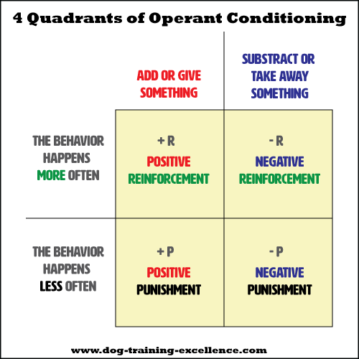The four possibilities are often explained using this 4 quadrant chart.
2K+

Here is an example:
You give (positive) your canine friend a pat on the head (reinforcement?) every time he sits next to you. So you can assume that is “positive reinforcement”
Well, no, it’s not what you are thinking...
You notice that your dog does not sit next to you more often, it actually happens less often!
You rewarded him with a pat! why isn’t he sitting next to you? …
… because the pat on the head was not a reward for him. He actually hates when you pat him on the head! (some dogs really do, if this is your case, rubbing down the chin is better).
So, you did give (positive) him something - the pat on the head - BUT there is a behavior that happens less often (punishment).
You just used positive punishment!
A reward is only a reward if the animal increases the likelihood of the behavior!
An aversive event is only a punishment if the animal decreases the likelihood of the behavior!

