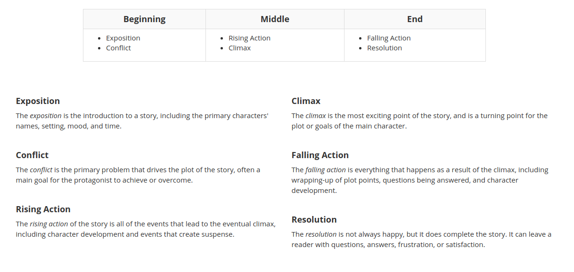
STORY ARC BREAKDOWN
*Taken from http://www.storyboardthat.com/articles/e/plot-diagram

